*BioScience* cover image submission

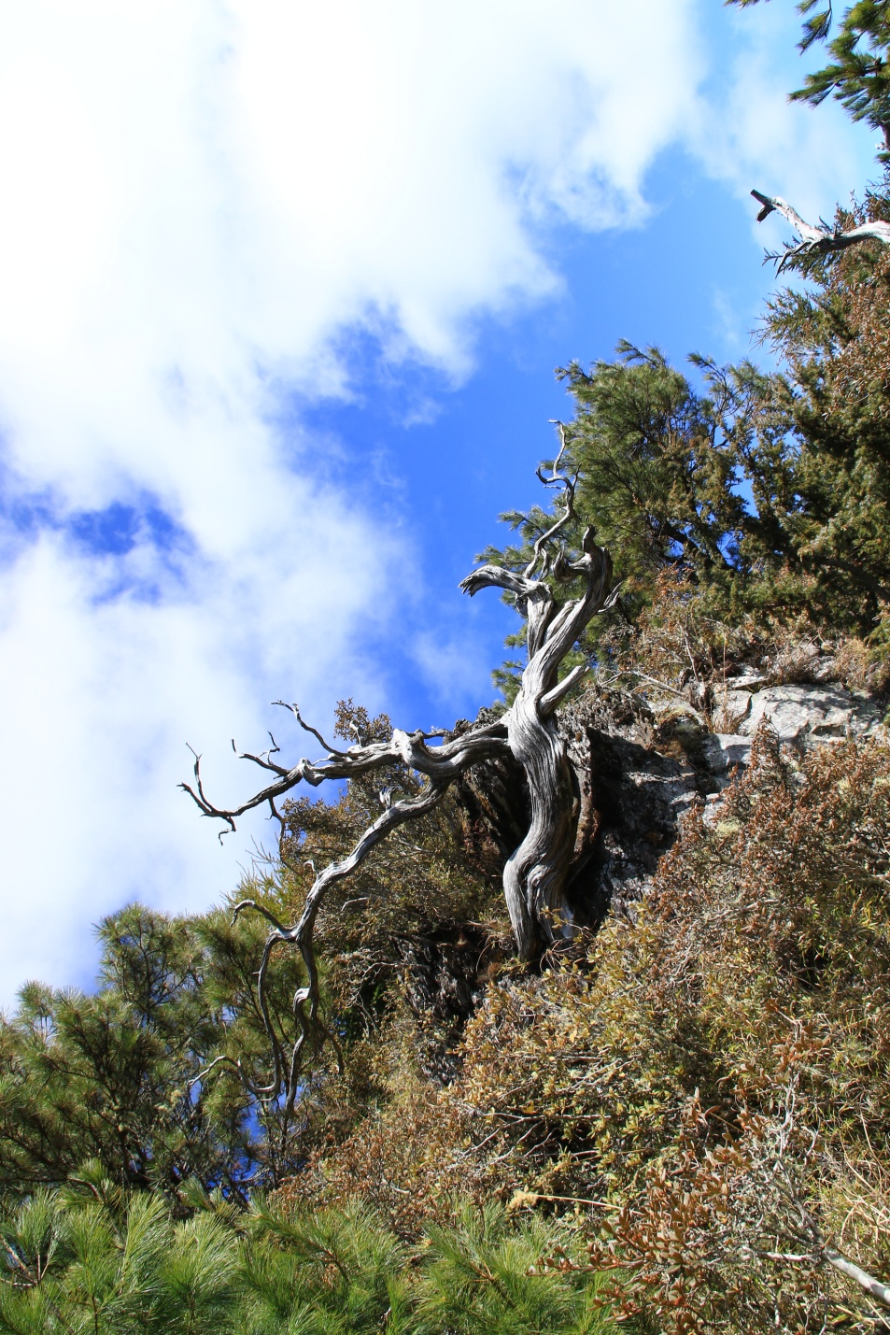

A twisting dead stand of single-seed juniper *Juniperus morrisonicola*Hayata. Single-seed juniper is the highest-altitude tree species in Taiwan and survives harsh conditions of freezing temperature and strong wind. Photograph: Gen-Chang Hsu.